Change to the #include:  
 I added “src/” to the #include “functions.h” so that it became “src/functions.h”. This will allow the driver.c file to find the functions.h file that is now in the src directory.

Screenshot 1:

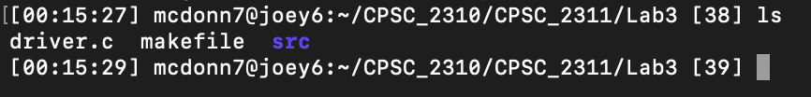

Screenshot 2:

Screenshot 3:

Screenshot 4:

Screenshot 5:A screen shot of a computer

Description automatically generated

Screenshot 6:

Screenshot 7:

